**STATIC ROUTING**

**INITIAL SETUP:**

Create 2 LANS each LAN Contain 1 router, 1 switch, 2 PCs

Connect PCs with Switch and then Switch with Router Using Wire

**Procedure:**

* Assign IP of class A to 1st Lan and IP of class C to 2nd Lan Just like Given below 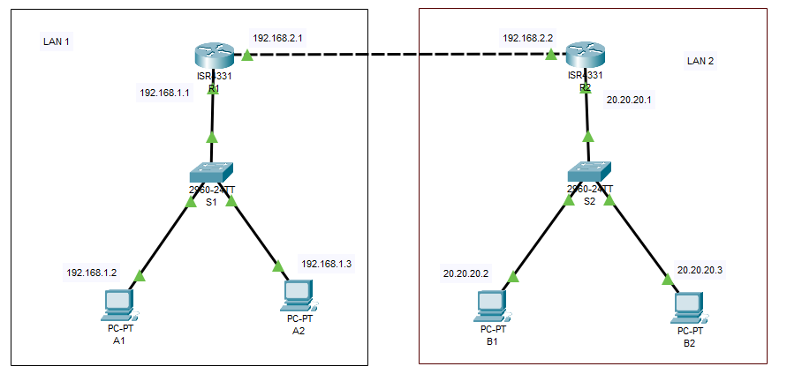
* Now click on Router R1 and under Config portion click on Static
* Now fill given portion accordingly
  + Netwok: IP of Network of Lan 2 (20.0.0.0)
  + Mask: Subnet Mask of Network IP
  + Nexthop: IP address of port of router to which this router is connected

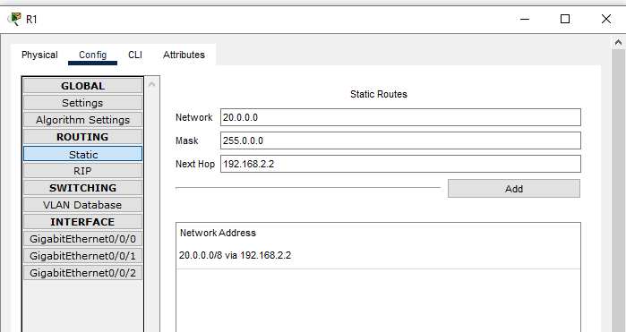

* Same Above Work with router R2

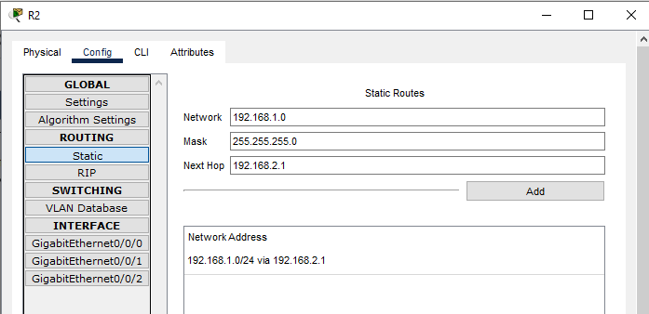

* Now You can ping PCs of Lan1 with Lan2
* 